7 Reasons Why Pocket Pistols May Not Be For You
by B. GIL HORMAN posted on July 24, 2014
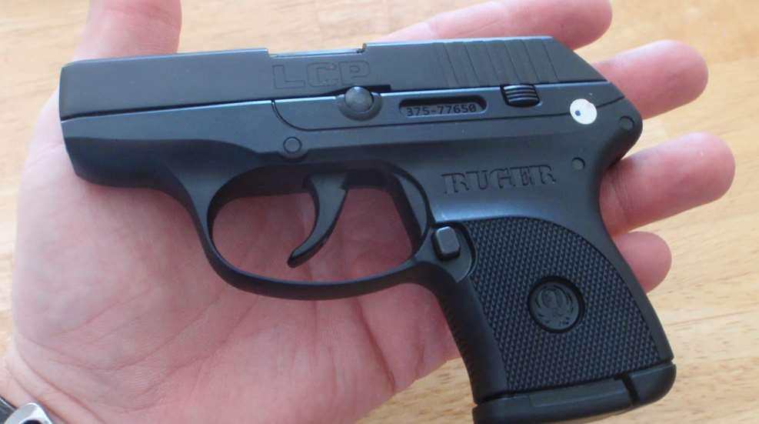
Over the last few years, pocket-sized pistols have dominated the concealed-carry handgun market. More makes and models of these ultra-compact, lightweight defensive firearms are available than ever before. As someone who owns, shoots and packs these diminutive guns, I appreciate both their convenience for daily carry and their usefulness when larger defensive options cannot be employed. However, pocket pistols have certain limitations that new or inexperienced hand-gunners need to be aware of before they commit to buying one:
1. To make a pistol easier to pocket, the grip size is usually the first thing to shrink. Short grips can leave one, or even two, of shooting-hand fingers with nothing to hold. This in turn can make the gun hard to manage when forming a sight picture and during recoil.
2. Shrinking a handgun's size reduces the amount of ammunition it can hold. Snub-nose revolvers usually hold just five rounds, while semi-automatics can hold as little as six rounds in the magazine. How many rounds a handgun has ready to fire, and how often it must be reloaded, becomes an important factor when a self-defender is faced with multiple threats.
3. Small pistols provide less stopping power than larger handguns. In some cases, this is because the handgun is chambered for a smaller cartridge such as the .380 ACP, .32 ACP, or .22 Long Rifle. When it comes to pocket pistols chambered for larger rounds, including the .38 Special, .40 S&W and .45 ACP, the pistol's abbreviated barrel reduces the amount of velocity a bullet can develop before it leaves the gun. While there may not be too much energy loss in some models, others can produce a substantial drop.
4. Be prepared for puny sights. To facilitate a quick draw from a pocket or purse, these pistols often have small sight systems ranging from merely functional to nearly vestigial. A few of the smallest and sleekest versions have no sights at all. The lack of useful sights will affect shot placement.
5. Pocket pistols often have triggers that are tough to work with. Whether it is the nature of the gun's mechanism (double-action revolvers) or the safety concerns of the manufacturer (semi-automatics), plenty of pocket pistols leave the factory with a long, heavy trigger pull. Some require as much as 12 to 15 pounds of pressure to cycle, which is quite a bit compared to the 4 to 6 pounds of trigger pull commonly found on many full-size striker-fired pistols these days.
6. Plan on experiencing more felt recoil. No matter what the caliber may be, from the pithy .25 ACP to the mighty .45 ACP, reducing the overall mass of a pistol results in more recoil energy being transferred to the shooter. In other words, a cartridge that's comfortable to shoot in a full-size handgun can turn a pocket-sized gun into a hand-pounding jackhammer.
7. Pocket pistols on the whole are less accurate than larger defensive handguns. Yes, it's true that Jerry Miculek can hit a target at 200 yards with an upside down J-Frame air weight revolver, but then again, he's one of the greatest professional shooters of all time. For us mere mortals, pocket pistols tend to be short-range personal-protection tools with the best practical defensive accuracy often found somewhere at or below 15 yards in distance.
So, are pocket pistols "bad" guns? No, they're not, when they are used for their intended purpose of close-range personal defense when larger guns have to be left at home.
But they are a class of firearm that requires more time and energy to learn to fire effectively.
If you are considering a pocket pistol for concealed carry, try it before you buy it by borrowing one from a friend or renting it from a shooting range. Then be prepared to practice with it until you get the hang of it.

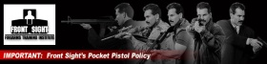
Dr. Ignatius Piazza
Wednesday, January 12, 2022
Dear Allen,

Front Sight's Pocket Pistol Policy
Handguns smaller than a Glock 26 are considered "pocket pistols" and are not allowed at Front Sight. Although "any gun will do if you will do," pocket pistols are inappropriate for Front Sight courses. Due to their small size, pocket pistols are difficult to manipulate, painful to shoot, and often less safe because the user is more likely to cover their support hand or other body parts with the muzzle. Learn our techniques using a mid-size handgun (such as a Glock 19) or full-size handgun (such as a Glock 17). After you have mastered the techniques, if you chose to carry a compact or subcompact "Pocket Pistol" you will have the skills and knowledge to do so safely.
We arbitrarily define a "pocket pistol" as any handgun smaller in size than a Glock 26 (roughly 6.4" slide length and 4.2" frame height). In other words, any handgun used at Front Sight must be at least 6.4" long (from muzzle to rear tang) AND 4.2" tall (from bottom of the inserted magazine to the top of the rear sight. Below is a photo of the Glock 26 showing those measurements:
Our definition of "pocket pistol" includes a number of very popular handguns such as:
- Glock 43: UPA Approved
- Sig P365: UPA Approved
- Smith &Wesson M&P 9 Shield Model 2.0: UPA Approved
- Ruger LC9
- And hundreds of others, (Bersa, All Hi-Points, Wather PP-PPK, S/W Bodyguard)
Determine if your handgun is appropriate for Front Sight training by doing one of the following:
- Call our Concierge Department at 702-837-7433. Tell us the make and model of the handgun you are considering and we will do the research to determine if it is suitable for your course.
- Measure your weapon as defined above in the orientation shown in the photograph.
- Go to handgunhero.com and compare your weapon to a Glock 26. The best view is "facing up" such as in the photograph below. Remember, your weapon needs to satisfy BOTH the length and height requirements.
Glock 26 on the left and Sig P365 on the right. While the frames are roughly the same dimension, the slide length of the Sig P365 is significantly shorter than the Glock 26. The Sig P365 is therefore not allowed for training at Front Sight.
Front Sight's "pocket pistol" policy has been in effect since we opened our doors back in April of 1996. However, over the past five years, we had a staff member who made so many "case-by-case exceptions" that the policy was effectively voided. That was a mistake. The policy exists for good reason and we are strictly adhering to it from this point forward. Even if you have previously trained with a pocket pistol at Front Sight, you must now adhere to the standard defined above.
Please verify your weapon passes the above test before you leave home. We inspect all weapons at Front Sight to verify they are safe and appropriate for use in your course. If you bring a weapon that fails the "pocket pistol test," you will need to use a secondary weapon or rent one from us.
Remember, we do not allow any handgun calibers smaller than 9mm. In other words, we do not allow .380, .32, or .25. Under rare exceptions, we do allow handguns chambered in .22 long rifle if the shooter has a specific need for reduced recoil such as an injury, arthritis, missing fingers, etc. Even under those circumstances, the weapons cannot be a "pocket pistol" and must still adhere to the above size standards.
Sincerely,
Dr. Ignatius Piazza
Founder and Director
Front Sight Firearms Training Institute
#1 Front Sight Road
Pahrump, NV 89061
https://www.frontsight.com
info@frontsight.com
1.800.987.7719

UPA Pocket Pistol Policy
Handguns smaller than a Glock 26 are considered "pocket pistols" and are not allowed for the CPL/CCW First Time or Renewal Class at UPA RANGE.
(These are allowed for lessons, but not recommended until student has had at least one prior lesson. See below for UPA Lesson Pocket Pistol Policy)

WHY? Due to their small size, pocket pistols are difficult to manipulate, painful to shoot, and often less safe because the user is more likely to cover their support hand or other body parts with the muzzle.
After you have mastered the techniques, if you chose to carry a compact or subcompact "Pocket Pistol" you will have the skills and knowledge to do so safely.
(See the attached NRA article 7 Reasons Why Pocket Pistols May Not Be For You)
Note: Based on the aforementioned article and personal experience: UPA clearly defines a "pocket pistol" as any handgun smaller in size than a Glock 26 (roughly 6.4" slide length and 4.2" frame height). See the article “Front Sight’s Pocket Pistol Policy”.
Determine if your handgun is appropriate for UPA training by doing one of the following:
- Call us at 586-332-0056. Tell us the make and model of the handgun you are considering and we will do the research to determine if it is suitable for your course.
- Measure your weapon as defined above in the orientation shown in the photograph.
- Go to handgunhero.com and compare your weapon to a Glock 26. The best view is "facing up" such as in the photograph below. Remember, your weapon needs to satisfy BOTH the length and height requirements.
- Please verify your weapon passes the above test before you leave home. We inspect all weapons at UPA prior the CPL or Renewal Class to verify they are safe and appropriate for use in your course. If you bring a weapon that fails the "pocket pistol test," you will need to have an approved lesson prior to; or use a secondary weapon; or rent one from us.

UPA Lesson Pocket Pistol Policy:
At your first lesson with a pocket pistol, you will begin with a .22 caliber pistol. At the sole discretion of the instructor, if you are safe and accurate, you will then be allowed to switch and complete the lesson with your pocket pistol. The instructor always reserves the right to have you switch back to the .22 pistol if you are unable to handle the pocket pistol safely and/or accurately.

